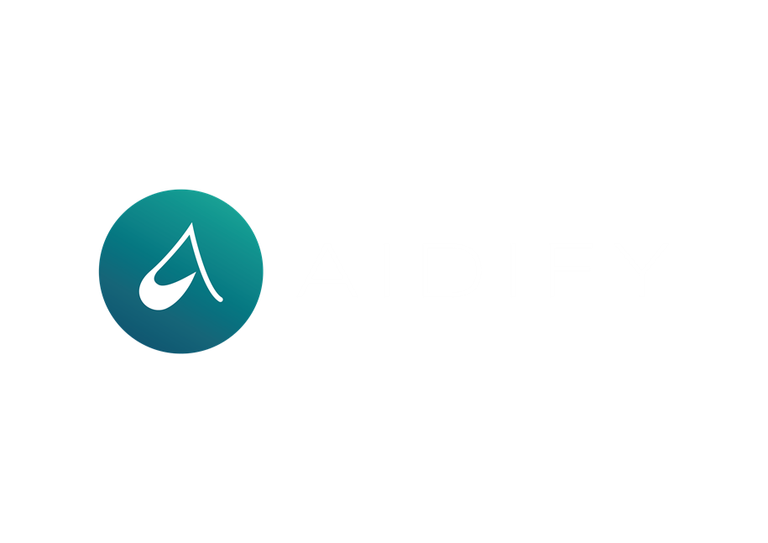

LEARN. **GROW.** AIDIFY.

**RESOURCE HUB**

**FOR GXP MANAGERS**

**© Copyright by AIDIFY Sp. z o.o. All rights reserved.**

**TOP SECRET | Trade secret of AIDIFY sp. z o.o.**



Use these questions to encourage open dialogue and gain deeper insights during feedback sessions.

**1. Self-Reflection**

* "How do you feel about your recent performance?"
* "What are your thoughts on how the project is progressing?"
* "In what areas do you believe you've excelled?"
* "Are there aspects of your work you're particularly proud of?"
* "What do you think went well, and what could have been better?"
* "How do you assess your contribution to the team's goals?"
* "What lessons have you learned recently?"
* "How satisfied are you with your current role?"
* "What motivates you most in your work?"
* "How do you define success for yourself in this project?"
* "Can you share an achievement that was especially meaningful to you?"
* "How have your goals evolved over time?"

**2.Challenges and Obstacles**

* "What challenges have you encountered?"
* "Are there any obstacles that have hindered your work?"
* "How have you addressed difficulties you've faced?"
* "Can you describe a recent setback and how you managed it?"
* "What resources do you need to overcome current challenges?"
* "Are there processes that you find particularly cumbersome?"
* "What barriers are preventing you from performing at your best?"
* "How can I or the team support you in overcoming these obstacles?"
* "Have there been any unexpected issues impacting your work?"
* "What strategies have you tried to deal with these challenges?"
* "What did you learn from overcoming past obstacles?"
* "Is there anything that consistently disrupts your workflow?"

**3. Process and Approach**

* "Can you walk me through your approach to this task?"
* "What strategies did you find most effective?"
* "How do you prioritize your tasks and responsibilities?"
* "What criteria do you use when making decisions?"
* "Can you share how you plan and organize your work?"
* "What steps do you take when starting a new project?"
* "How do you ensure quality and accuracy in your work?"
* "What methods have you found helpful for managing your time?"
* "How do you adapt your approach when facing new challenges?"
* "What tools or techniques do you rely on most?"
* "How do you balance multiple competing priorities?"
* "What influences your approach to problem-solving?"

**4. Communication and Collaboration**

* "How do you feel about the communication within the team?"
* "Are there ways we can improve our collaboration?"
* "How do you prefer to receive information and updates?"
* "Can you share an example of effective teamwork you've experienced?"
* "What do you think about the feedback processes we have in place?"
* "How do you handle conflicts or disagreements with colleagues?"
* "What can we do to foster better communication?"
* "How comfortable are you sharing your ideas with the team?"
* "Do you feel your contributions are valued and heard?"
* "What suggestions do you have for enhancing team meetings?"
* "How can we better support each other in our roles?"
* "Are there communication barriers we need to address?"

**5. Support and Resources**

* "What support do you need to achieve your goals?"
* "Are there resources that could assist you?"
* "Is there any training or development you'd find beneficial?"
* "How can management better support your efforts?"
* "Do you have the tools necessary to perform your job effectively?"
* "Are there any roadblocks we can help remove?"
* "What additional information would help you in your role?"
* "How can we make your work environment more conducive to productivity?"
* "Are there mentoring opportunities you'd like to explore?"
* "What feedback would you like to give about the support you receive?"
* "Do you feel equipped to handle your current workload?"
* "How can we facilitate access to the resources you need?"

**6. Impact and Consequences**

* "How do you think your actions have affected the team?"
* "What do you believe is the impact of this situation?"
* "Can you describe how your work contributes to our overall goals?"
* "What are the short-term and long-term effects of your decisions?"
* "How does your role influence other departments or stakeholders?"
* "In what ways do you think your performance affects team morale?"
* "What impact do you hope to make in this project?"
* "How do you measure the success of your contributions?"
* "What feedback have you received from others about your impact?"
* "How might changes in your approach affect outcomes?"
* "How do you think clients perceive your work?"
* "What legacy do you want to leave within the team?"

**7. Future Improvements**

* "What steps do you think we can take to improve?"
* "How can we work together to address this issue?"
* "What ideas do you have for enhancing our processes?"
* "Where do you see opportunities for growth in your role?"
* "How can we better align our efforts with our goals?"
* "What changes would you suggest for future projects?"
* "How can we prevent similar challenges moving forward?"
* "What additional responsibilities are you interested in taking on?"
* "What support do you need to implement these improvements?"
* "How do you envision your career progressing here?"
* "What new initiatives would you like to see introduced?"
* "How can we innovate in our current practices?"

**8. Personal Development**

* "What are your professional development goals?"
* "In which areas do you wish to grow or improve?"
* "How can we support your career aspirations?"
* "What new skills are you interested in acquiring?"
* "Are there any workshops or courses you'd like to attend?"
* "How do you prefer to receive feedback on your development?"
* "What motivates you to perform at your best?"
* "Can you identify any mentors who could assist you?"
* "What challenges are you willing to take on for growth?"
* "How do you plan to achieve your development objectives?"
* "What strengths do you want to build upon?"
* "How do you stay current with industry trends?"

**9. Team Dynamics**

* "How do you feel about the team's collaboration?"
* "What can we do to enhance our team's effectiveness?"
* "Do you feel aligned with the team's goals and values?"
* "How would you describe the team's strengths?"
* "What areas do you think the team could improve upon?"
* "How do you contribute to the team's dynamic?"
* "What have you learned from your teammates?"
* "Are there any team-building activities you'd suggest?"
* "How can we celebrate our successes more effectively?"
* "What practices can we adopt to foster a positive team environment?"
* "How do you think we can improve trust within the team?"
* "What roles do you see yourself playing within the team?"

**10. Job Satisfaction**

* "What aspects of your job do you enjoy the most?"
* "Are there any parts of your role you find less satisfying?"
* "How do you feel about your work-life balance?"
* "What keeps you engaged and motivated at work?"
* "Is there anything that would increase your job satisfaction?"
* "Do you feel recognized for your contributions?"
* "How do you perceive your relationship with management?"
* "What changes would enhance your experience here?"
* "How satisfied are you with opportunities for advancement?"
* "What would make your work more fulfilling?"
* "Do you feel your job utilizes your skills effectively?"
* "How do you feel about the company's culture and values?"

**11. Feedback on Management**

* "How can I better support you as your manager?"
* "What feedback do you have for me?"
* "Are there ways I can improve our communication?"
* "Do you feel comfortable bringing issues to my attention?"
* "How effective am I at providing the guidance you need?"
* "What can I do to help you achieve your goals?"
* "Is there anything you'd like me to do differently?"
* "How can I assist in removing obstacles you face?"
* "Do you feel your feedback is valued and acted upon?"
* "What expectations do you have of me as your manager?"
* "How do you prefer to receive feedback from me?"
* "Are there decisions you'd like more involvement in?"

**12. Innovation and Ideas**

* "Do you have any ideas for new projects or initiatives?"
* "What suggestions do you have for improving our products/services?"
* "How can we encourage more creativity within the team?"
* "Are there industry trends we should be paying attention to?"
* "What technologies or methods could we adopt to enhance our work?"
* "How do you stay informed about developments in your field?"
* "What innovative practices have you seen elsewhere that we might consider?"
* "How can we create an environment that fosters innovation?"
* "What problems have you identified that need solutions?"
* "How can we better support experimentation and risk-taking?"
* "What unmet needs do you see in our market?"
* "How do you think we can differentiate ourselves from competitors?"

**13. Workplace Environment**

* "How do you feel about the physical work environment?"
* "Are there any changes that would improve your comfort or productivity?"
* "Do you feel safe and respected at work?"
* "What can we do to promote a positive workplace culture?"
* "Are there any workplace policies you'd like to discuss?"
* "How do you feel about the level of transparency within the organization?"
* "What initiatives could enhance employee well-being?"
* "Do you have suggestions for improving workplace diversity and inclusion?"
* "How can we better support work-life balance?"
* "What activities or events would you like to see implemented?"
* "How do you feel about remote work options?"
* "What traditions or practices would you like to see started?"

**14. Customer/Client Feedback**

* "What feedback have you received from customers/clients?"
* "How can we improve our customer service?"
* "What do you think our clients value most about our work?"
* "Are there client concerns we need to address?"
* "How can we enhance our relationships with customers?"
* "What have you learned from recent client interactions?"
* "Do you have ideas for expanding our client base?"
* "How do you handle customer complaints or issues?"
* "What success stories can you share about client satisfaction?"
* "How can we better meet the needs of our customers?"
* "What trends are you noticing in client expectations?"
* "How can we exceed client expectations?"

**15. Goals and Objectives**

* "Are your personal goals aligned with the team's objectives?"
* "What do you hope to achieve in the next quarter?"
* "How can we ensure your goals are met?"
* "Do you understand how your work contributes to our mission?"
* "What metrics do you use to measure your success?"
* "Are there any goals you feel are unrealistic or need adjustment?"
* "How can we better support you in reaching your targets?"
* "What accomplishments are you most proud of?"
* "How do you prioritize competing demands?"
* "What strategies do you use to stay focused on your goals?"
* "What long-term goals do you have within the company?"
* "How do you adapt when priorities change?"

**16. Open Forum**

* "Is there anything else you'd like to discuss?"
* "Do you have any suggestions or ideas you'd like to share?"
* "Are there questions you have that we haven't covered?"
* "What topics would you like to explore in future meetings?"
* "Is there feedback you'd like to provide about the team or organization?"
* "Do you have concerns you'd like to address?"
* "How can I assist you further?"
* "What has been on your mind lately regarding work?"
* "Are there any successes you'd like to celebrate?"
* "How can we improve these feedback sessions?"

**Additional Tips:**

* **Active Listening:**
  + Give your full attention and avoid interrupting.
  + Show understanding by nodding and providing affirmations.
  + Summarize or paraphrase to confirm understanding.
* **Encouragement:**
  + Show appreciation for their honesty and insights.
  + Encourage them to elaborate with phrases like "Tell me more about that."
  + Validate their feelings and perspectives.
* **Clarification:**
  + Ask follow-up questions if you need more information.
  + Avoid making assumptions; seek to understand fully.
  + Clarify any ambiguities before moving on.
* **Non-Judgmental Attitude:**
  + Keep an open mind and avoid expressing judgment.
  + Focus on the conversation, not on forming responses.
  + Be respectful of differing opinions.
* **Body Language:**
  + Maintain appropriate eye contact.
  + Use open and welcoming gestures.
  + Be mindful of your facial expressions.
* **Confidentiality:**
  + Ensure that sensitive information is kept private.
  + Build trust by respecting confidentiality.
* **Empathy:**
  + Try to understand their feelings and perspectives.
  + Acknowledge emotions and respond with compassion.
* **Solution Focused:**
  + Guide the conversation towards actionable solutions.
  + Encourage them to propose ideas for improvement.
* **Patience:**
  + Allow them time to think and respond.
  + Don't rush the conversation.
* **Follow-Up:**
  + Summarize key points and agreed actions at the end.
  + Set a time for follow-up discussions if necessary.